CYBIT110 Chapter 9 Skills Assessment 2 - Linux Networking

Background
The ifconfig Linux command has been deprecated in favor of iproute2 (the ip command) on Linux. Similarly, the arp, route and netstat commands are also deprecated. There are some Linux distros that still use ifconfig. Ubuntu does not.
The following table shows the summary of the exact deprecated commands and their replacements, that you should take note of.
Linux Deprecated Commands | Linux Replacement Commands
arp | ip n (ip neighbor)
ifconfig | ip a (ip addr), ip link, ip -s (ip -stats)
iptunnel | ip tunnel
iwconfig | iw
nameif | ip link, ifrename
netstat | ss, ip route (for netstat -r), ip -s link (for netstat -i), ip maddr (for netstat -g)
route | ip r (ip route)

IP addresses are assigned to physical interfaces, such as Ethernet Network Interface Cards (NICs). IP addresses can also be assigned to logical interfaces, such as a Local Loopback. An interface typically has only one IP address assigned to it, although it is possible to assign more than one IP address to an interface.
All TCP/IP hosts associate the IP address 127.0.0.1 as a loopback address. Usually the loopback interface, “lo” has the 127.0.0.1 address, with a mask of 255.0.0.0 or a /8

Required Equipment
- Ubuntu VM

Part 1 Understanding ip command
- Power on the Ubuntu VM and log in as cios with the password P@ssw0rd.
- Open a Terminal window and type ip and press Enter. The ip command cannot be executed by itself. It needs an object such as link, address, route, neighbor, tunnel, etc.
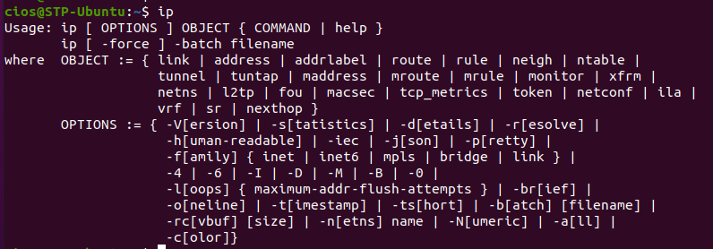
- To find the IP address information for all the interfaces, type the command ip address and press enter.
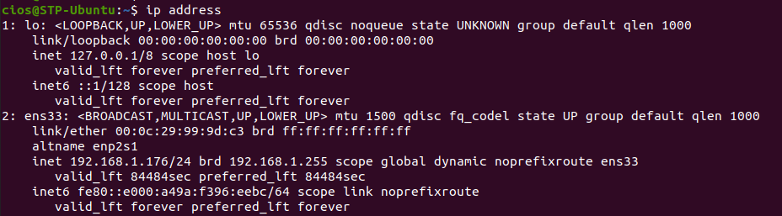
- Notice that for Ubuntu, there are two interfaces loopback (lo) and ens33. Ens33 is the ethernet interface. The key breakdown info for the above ens33 interface is the following:
- ens33: the network interface as a string. EN stands for ethernet and s33 stands for slot number.
- <BROADCAST,MULTICAST,UP,LOWER_UP>: This interface supports broadcast and multicasting, and the interface is UP (operational and connected). The hardware layer of the network (layer one) is also UP.
- mtu 1500: the max transfer unit the interface supports
- state UP: the interface is operational and connected
- group default: the interface is in the default interface group
- link/ether: the MAC address for the interface
- inet 192.168.1.242/24: IPv4 address with the prefix (/24) or subnet mask
- brd 192.168.1.255: the broadcast address for the subnet
- scope global: the IP address is valid everywhere on this network
- dynamic: the IP address is lost when the interface goes down
- ens33: the interface with which the IP address is associated with
- valid_lft: valid lifetime – the time the IP address will be considered valid
- preferred_lft: preferred lifetime – the time the IP address will operate without any restriction
- inet6: the IPv6 address with scope, valid_lft, and preferred_lft.
- To view the IP address information for a specific interface such as ens33 using the ip command, type the command: ip addr show dev ens33
- Insert a screenshot showing the result.
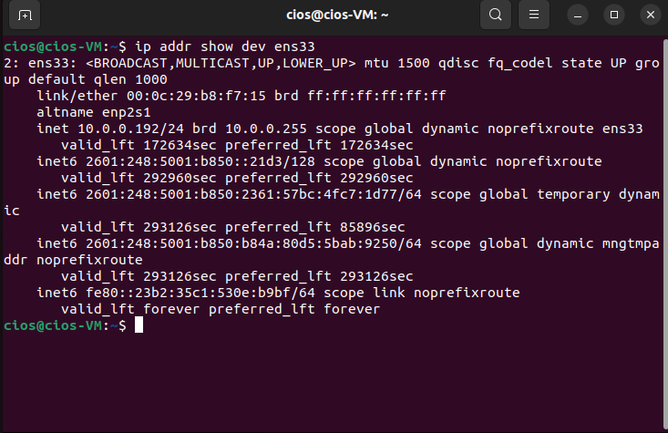
- What is the MAC address of your VM’s NIC?
00:0c:29:b8:f7:15 brd ff:ff:ff:ff:ff:ff
- What is the IP address/prefix of your Ubuntu VM?
10.0.0.192/24
- Leave Terminal open for next part.

Part 2 Configure IP Address
- To configure your ens33 interface with an IPv4 address of 192.168.100.X (for X, choose a number between 200 and 225) and a subnet mask of 255.255.255.0, type sudo ip addr add 192.168.100.X/24 dev ens33 and press enter. Enter the password P@ssw0rd when prompted.
- To confirm the IP address was added, type ip addr show dev ens33 and press enter.
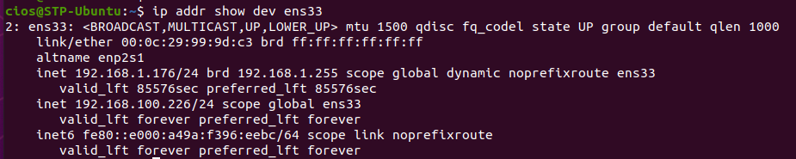
- Insert a screenshot show the IP address.
- 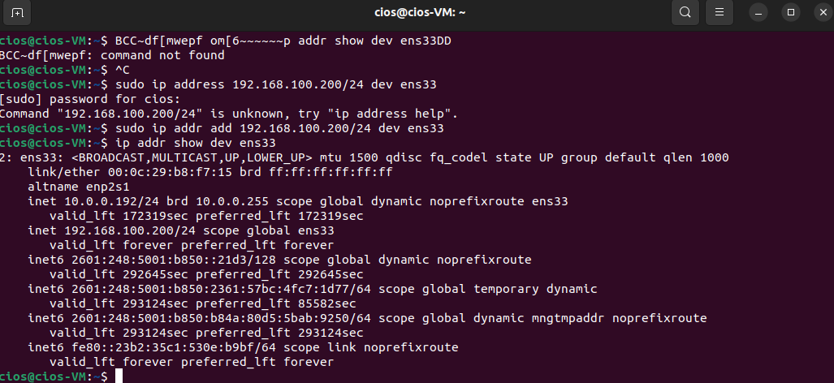
- To test the configuration, type ping X.X.X.X -c4 (X.X.X.X will be IP address from Step 1 that you configured) and press enter. There should be four successful results.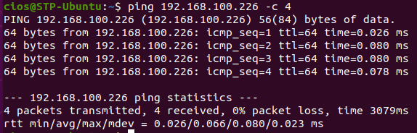
- Insert a screenshot showing the successful results of the ping.
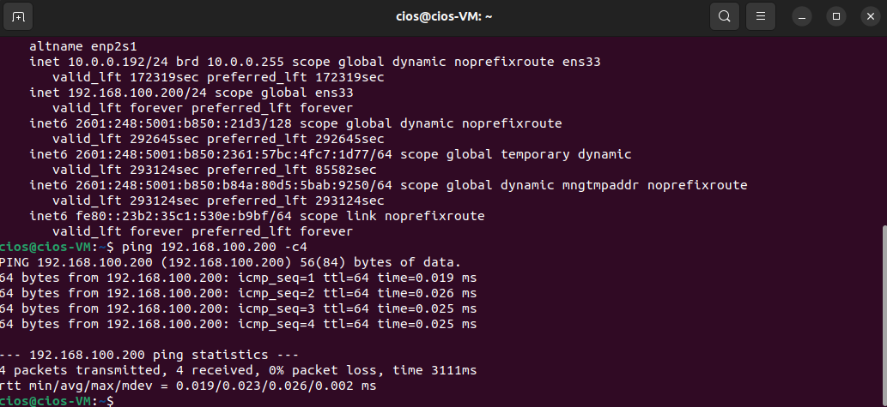
- When you use ip command to configure the IP address, it is only temporary; it will revert to permanent settings (such as using DHCP) at the next boot. Type the command reboot and press enter.
- Log back in.
- Open a terminal and type ip addr show dev ens33 and press Enter. The IP address that you configured should not be displayed.
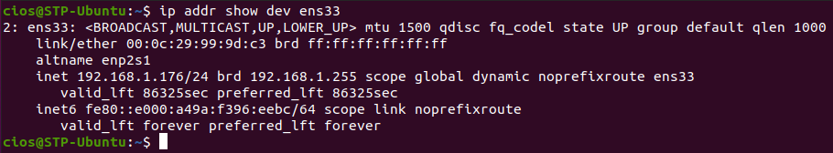
- Leave terminal open for next part.

Part 3 Identifying Default Gateway and ARP
- The ip addr show output does not provide the default gateway IP address. In order for Ubuntu to communicate with TCP/IP hosts beyond the local subnet, the system must use the services of a local router. The term “gateway” was commonly used in the past to refer to a router because a router acts a gateway to other networks. When configuring a host for IP, you may also have to configure its default gateway, which is the IP address of the local router’s interface. In the Linux CLI, you can manually configure the default gateway using the ip route command
- Type the command ip route show and press Enter. You will see your default gateway (in yellow box) and your network address/prefix (in orange box).
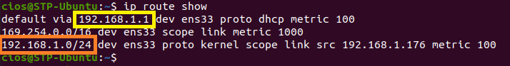
- Insert a screenshot showing the result.
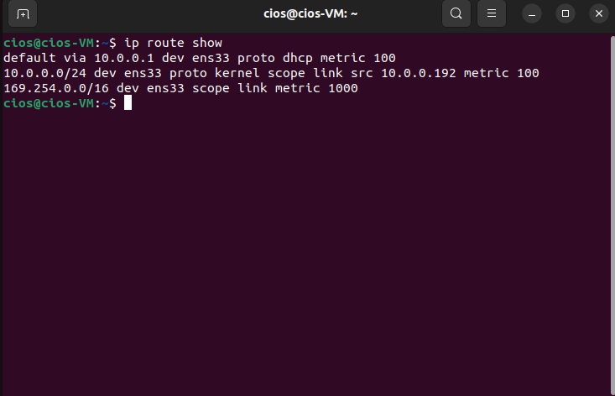
- Record your default gateway.
10.0.0.1
- Record the network address/prefix.
10.0.0.0/24
- In Linux, the arp command can display or manipulate the kernel's IPv4 network neighbor cache. ARP command is deprecated so you must use ip neighbor
- In Terminal, type the command ip neighbor and press Enter. The results should be nothing. It will return the next prompt. If you were communicating with another device in the network, then there would be an entry.
The output shows the MAC addresses of devices which are part of the system and their state. The state of a device can be:
- STALE – The neighbor is valid, but is probably already unreachable, so the kernel will try to check it at the first transmission.
- DELAY – A packet has been sent to the stale neighbor and the kernel is waiting for confirmation.
- REACHABLE – The neighbor is valid and reachable until the timeout expires.
- PERMANENT– signifies a permanent or static entry that only an administrator can remove
- Insert a screenshot of the result
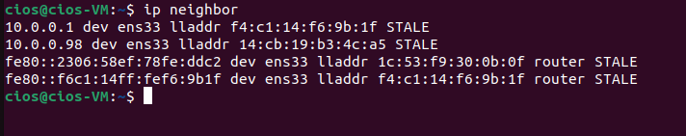

- Ping your default gateway with the command ping X.X.X.X -c 4 and press Enter. There will be four ping results.
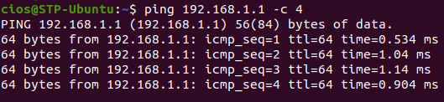
- Type the command ip neighbor. There should be a result for your communicating the default gateway.
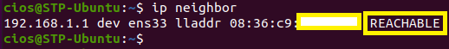
- Insert a screenshot of the result.
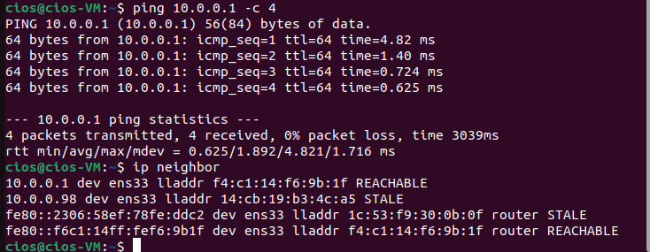
- Shutdown Ubuntu VM.

Resources
https://www.tecmint.com/deprecated-linux-networking-commands-and-their-replacements/
https://www.tecmint.com/ifconfig-vs-ip-command-comparing-network-configuration/
https://www.tecmint.com/ip-command-examples/

